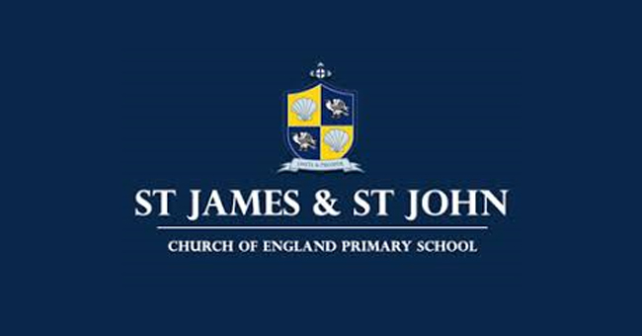

Teaching of French at St James and St John C of E School

Intent
St James and St John’s French scheme of work, aims to instil a love of learning and awareness of other cultures. We want pupils to develop the confidence to communicate in French for practical purposes, using both written and spoken French. Through our scheme of work, we aim to give pupils a foundation for language learning that encourages and enables them to apply their skills to learning further languages, developing a strong understanding of the English language, facilitating future study and opening opportunities to study and work in other countries in the future.

Implementation
We deliver French lessons weekly for 30 minute session from Year 3 onwards. We follow the Kapow scheme of work that is designed with six strands that run throughout.
- Speaking and pronunciation
- Listening
- Reading and writing
- Grammar
- Intercultural understanding
- Language detective skills
Each of our units cover the National Curriculum attainment targets. The progression document shows the skills that are taught within each year group and how these skills develop to ensure that attainment targets are securely met by the end of Key Stage 2.
Through Kapow Primary’s French scheme, pupils are given opportunities to communicate for practical purposes around familiar subjects and routines. The scheme provides balanced opportunities for communication in both spoken and written French, although in Year 3 the focus is on developing oral skills before incorporating written French in Year 4 and beyond. The scheme is a spiral curriculum with key skills and vocabulary revisited repeatedly with increasing complexity allowing pupils to revise and build on their previous learning. Cross- curricular links are included throughout our French unit, allowing children to make connections and apply their language skills to other areas of their learning.
Lessons incorporate a range of teaching strategies from independent tasks, paired and group work including role-play, language games and language detective skills. Through this, the children develop an understanding of French grammar rather than committing vast amounts of French vocabulary to memory. Differentiated guidance is available for every lesson. In order to help pupils retain their French learning, we provide information about how to incorporate French into the classroom environment every day in our ‘During the week’ sessions.
We aim to celebrate languages throughout the year through dedicated MFL days. We invite a specialist teacher to run a weekly French club at our infant site to encourage an early love of language.

Impact
Pupils are involved in the evaluation, dialogue and decision making about the quality of their outcomes and improvements they need to make. By taking part in regular discussions and decision making processes, children will not only know facts and key information about French, but they will be able to talk confidently about their own learning, have higher metacognitive skills and have a growing understanding of how to improve.
Each lesson plan provides guidance to support teachers in assessing pupils against the learning objectives. At the end of the unit, teachers can use unit quizzes and knowledge catchers to assess the impact of the sequence of lessons.
The French Lead can monitor the teaching of French through planning scrutiny, lesson observations, pupil voice, subject quizzes, staff dialogue and learning walks. Where further CPD is identified, staff are supported through coaching and team teaching and the use of CPD videos on Kapow.
Having followed the scheme throughout their primary school experience, pupils should leave school equipped with a range of techniques and the confidence and creativity to form a strong foundation for French learning at Key Stage 3 and beyond.
It is expected that all pupils will:
- Be able to engage in purposeful dialogue in practical situations (eg: Ordering in a café, following direction) and express an opinion
- Make increasingly accurate attempts to read unfamiliar words, phrases and short texts
- Speak and read aloud with confidence and accuracy in pronunciation
- Demonstrate understanding of spoken language by listening and responding appropriately
- Use a bilingual dictionary to support their language learning
- Be able to identify word classes in a sentence and apply grammatical rules they have learnt
- Have developed an awareness of cognates and near-cognates and be able to use them to tackle unfamiliar words in French, English and other languages
- Be able to construct short texts on familiar topics
- Meet the end of Key Stage 2 stage expectations outlined in the National Curriculum for languages

